SOP for clearing Messages from OSB Notification Server.
Login to Weblogic console.
http://172.20.10.60:7001/console/
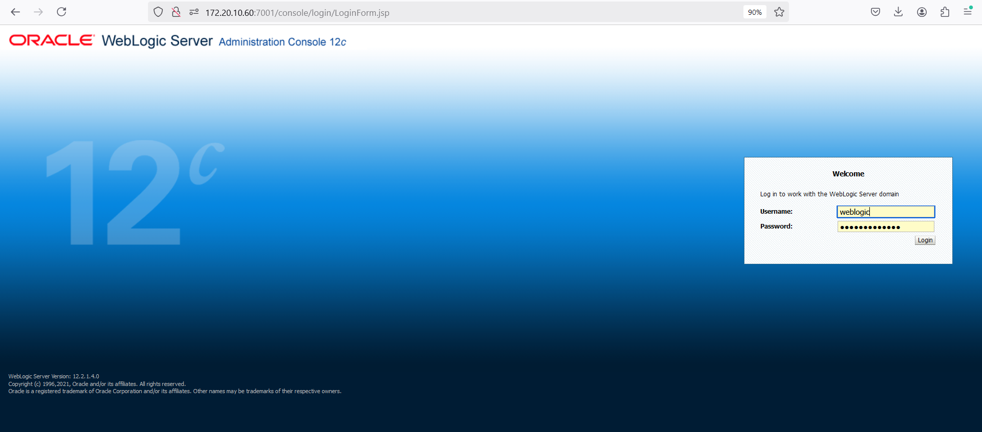

2.click on “JMS Module”
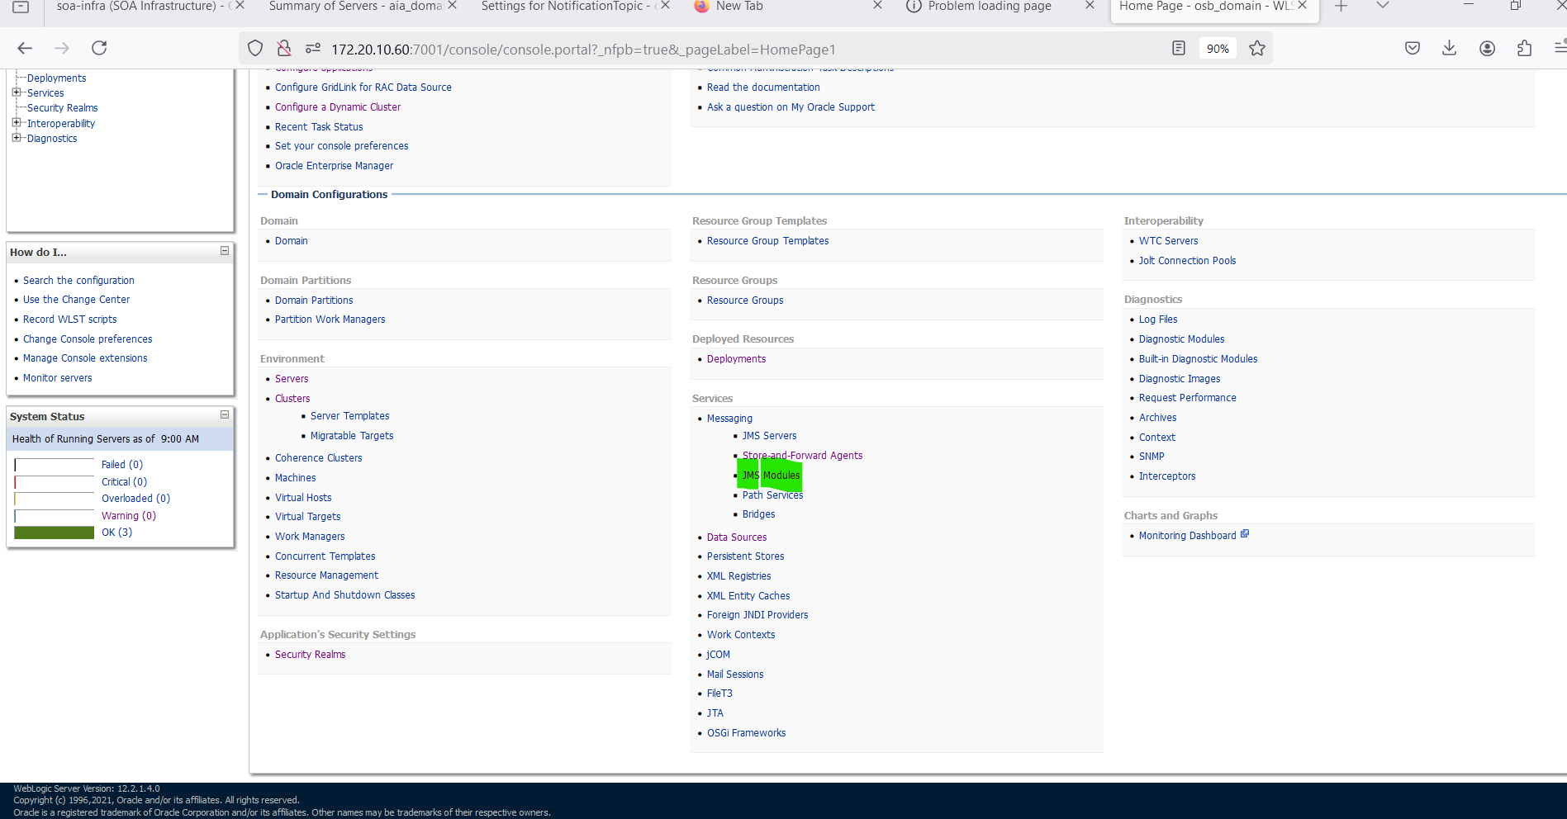
Click on ECE folder
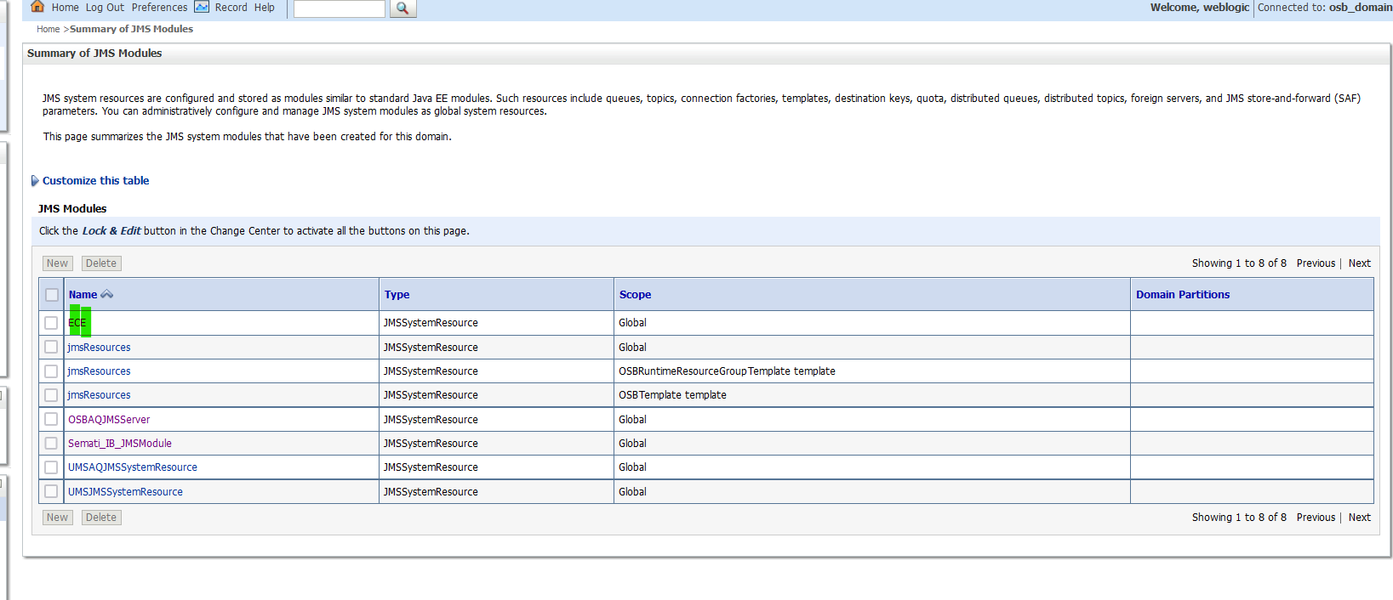

3.Click on NotificationTopic

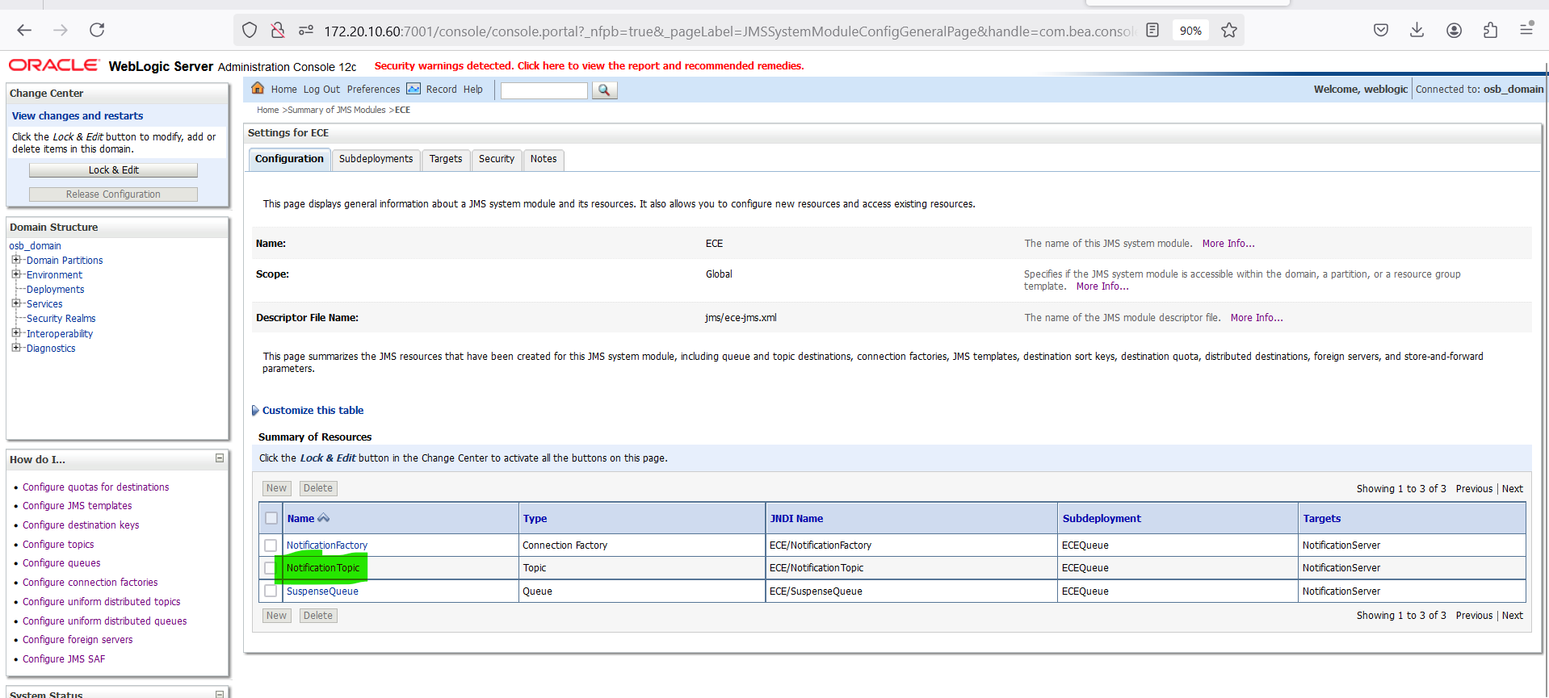
4.Navigate to MonitoringDurable Subscibers
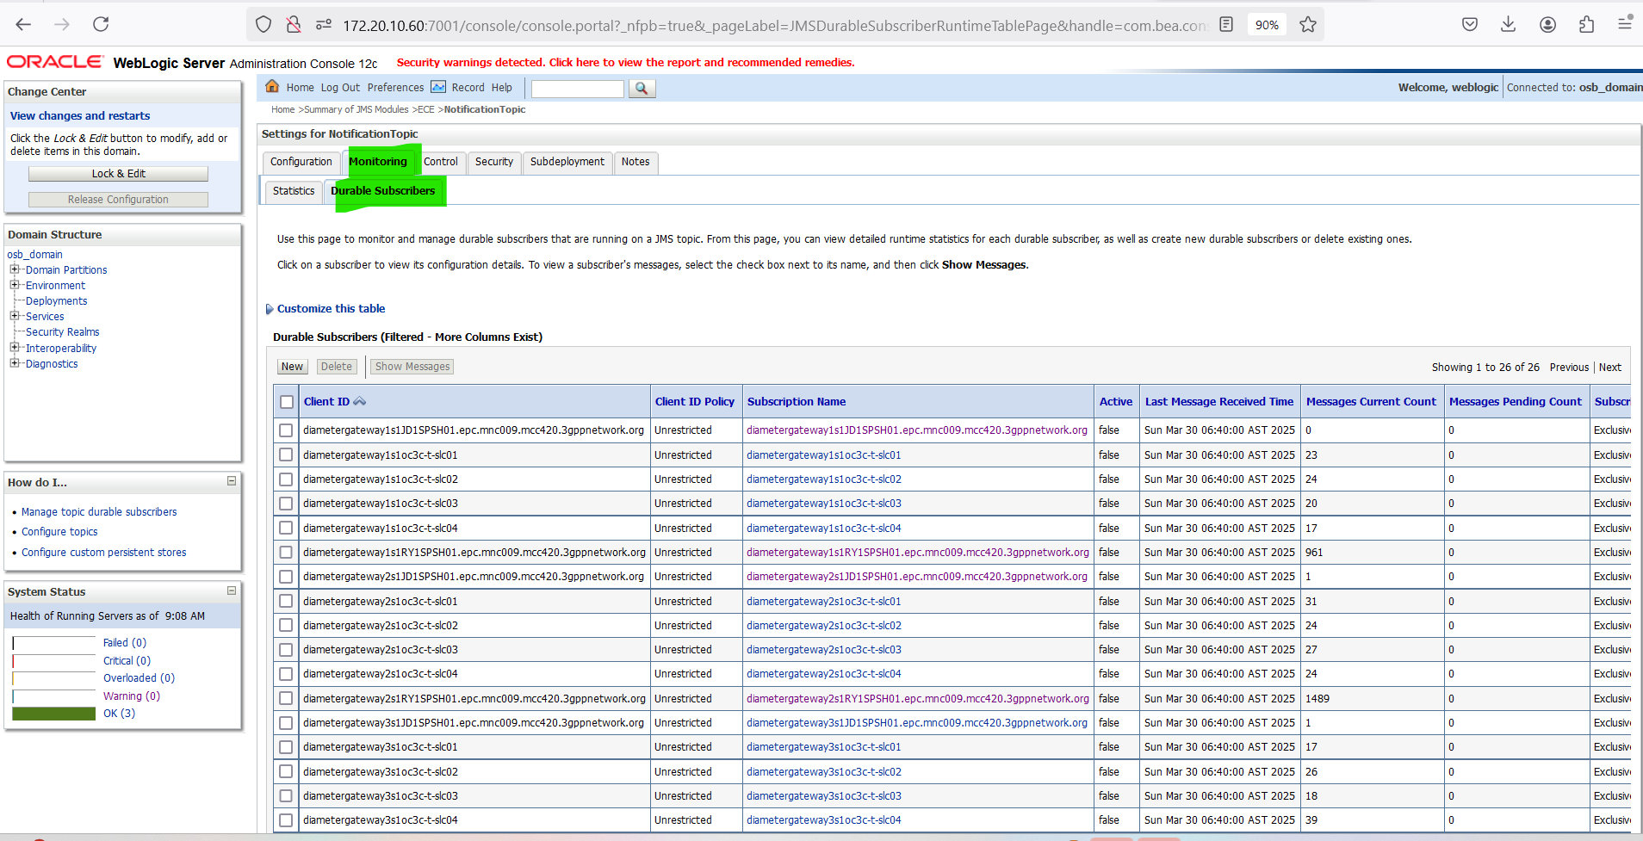

Select durableClient and show Messages Option
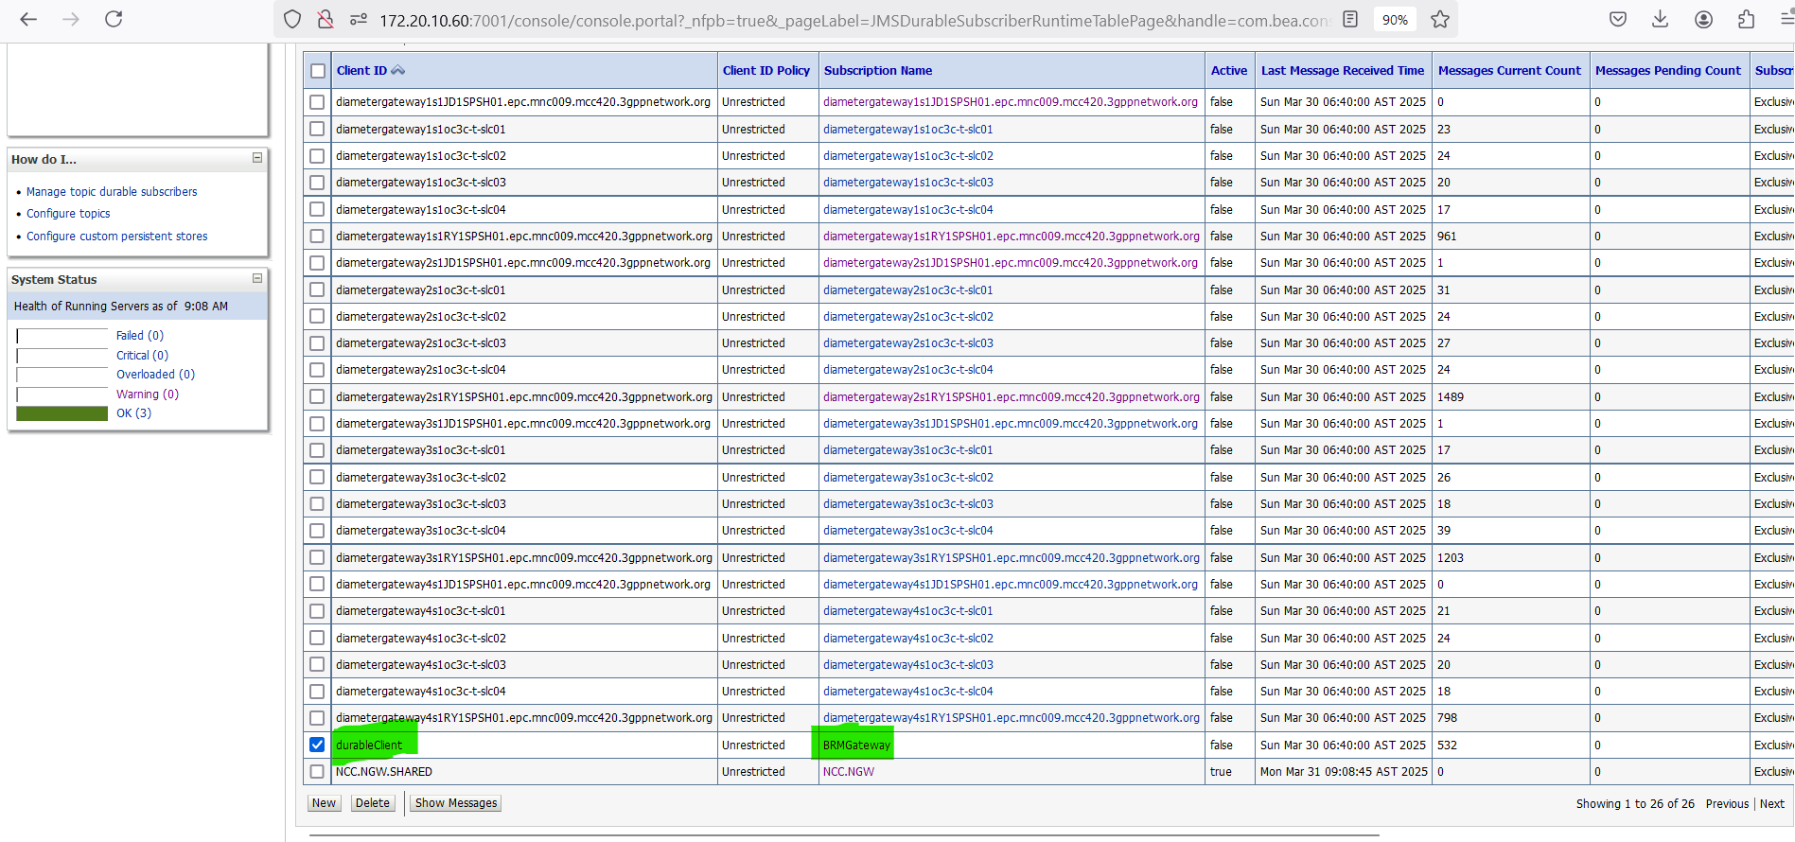

5. Select the ID as select click on Delete button

